10.15.20.60 IP Address-Class, Network IP Address, Direct broadcast address and Limited broadcast address

key features of UDP and real-time applications

IP header -reassembly of fragments

TCP connections - FTP

default port numbers for FTP control anddata connections?

default port number for Telnet and Telnet connection establishment with a remote host?

A host with IP Address 220.100.1.1 wants to send a packet to all the hosts in the same network.What will be- 1. Source IP Address 2. Destination IP Address

Working of DHCP

SMTP

NAT

TCP

ICMP

FTP

TELNET

SMTP

DHCP

elements of TCP protocol.

three main divisions of Domain System

ARP request

the role of Domain Resource Records (RRs) in the DNS and an example

If WAN link is 2 Mbps and RTT between source and destination is 300 msec, what would be the optimal TCP window size needed to fully utilize the line?

# transport layer protocol -transmitting data using FTP or Telnet

If the subnet mask 255.255.255.124 belongs to class C, find-Number of subnets, Number of hosts in each subnet

leaky bucket algorithm- improve the Quality of service in TCP

Consider a network with 6 routers R1 to R6 connected with links having weights as shown in the following diagram

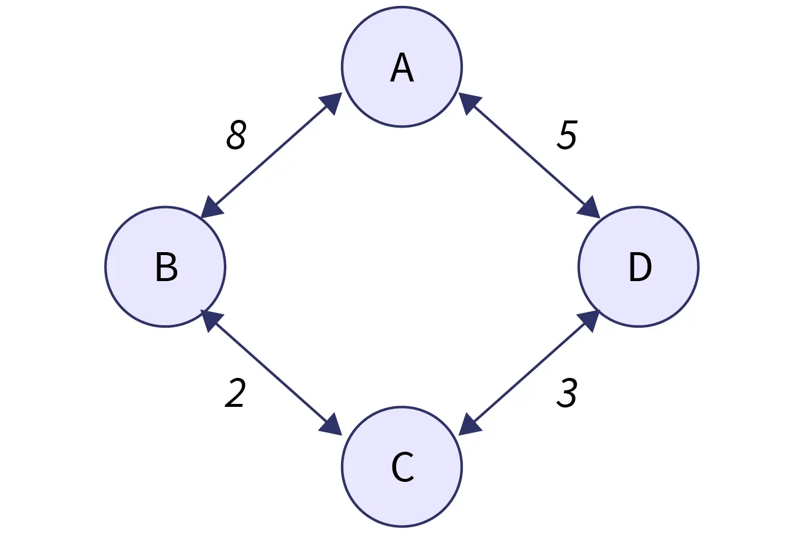

All the routers use the distance vector based routing algorithm to update their routing tables. Each router starts with its routing table initialized to contain an entry for each neighbour with the weight of the respective connecting link. After all the routing tables stabilize, how many links in the network will never be used for carrying any data?

A TCP machine is sending windows of 65538 B over a 1 Gbps channel that has a 10 msec one way delay. What is the maximum throughput achievable?

A n Internet Service Provider (ISP) has the following chunk of CIDR-based IP addresses available with it: 245.248.128.0/20. The ISP wants to give half of this chunk of addresses to Organization A, and a quarter to Organization B, while retaining the remaining with itself. Give the valid allocation of addresses to A and B?

Which header fields contribute to the reliable andordered delivery of data over a TCP connection?

A TCP machine is sending windows of 65538 B over a 1 Gbps channel that has a 10 msec one way delay.What is the maximum throughput achievable?

TCP, IP, UDP header format

three-way handshake process -Transmission Control Protocol (TCP).

Suppose host A is sending a large file to host B over a TCP connection. The two end hosts are 20 msec apart (40 msec RTT) connected by a 1 Gbps link. Assume that they are using a packet size of 1000 bytes to transmit the file. For simplicity, ignore ack packets. At least how big would the window size (in packets) haveto be for the channel utilization to be greater than 80%?

process of resolution of any website using recursive DNS server.

Draw the structure of the IPv4 header and identify and

explain the significance of at least five key fields. How

do these fields contribute to the routing and delivery of

IP packets across networks?

Describe the role of SMTP (Simple Mail Transfer Protocol) in the process of sending and receiving emails.

IP address 10.0.0.0/16. Subnet thisblock into subnets with a maximum of 500 hosts persubnet.Hosts Required, Number of Bits for Hosts, Subnet Mask, Subnet Ranges

keycomponents of DNS, the process of domain nameresolution, and the significance of DNS

What are the steps in link state routing algorithm? Explain each step in detail?

Consider a network with 6 routers R1 to R6 connected with links having

weights as shown in the following diagram

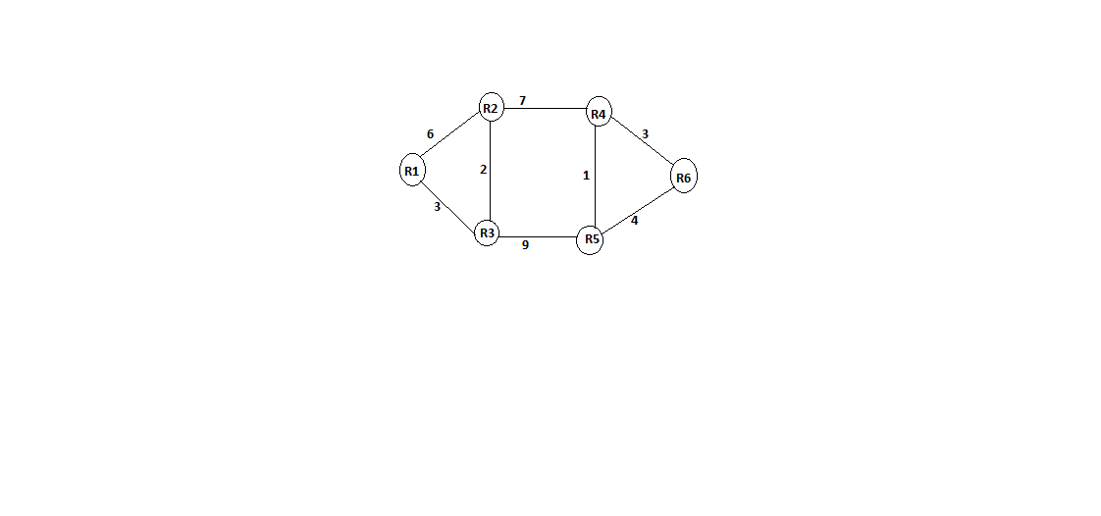

i. All the routers use the distance vector-based routing algorithm to update their routing tables. Each router starts with its routing table initialized to contain an entry for each neighbour with the weight of the respective connecting link.

After all the routing tables stabilize, how many links in the network will never be used for carrying any data

ii. Suppose the weights of all unused links in theprevious question are changed to 2 and the distancevector algorithm is used again until all routing tablesstabilize. How many links will now remain unused?

IP address 172.16.0.0/20. Subnet this address into eight subnets, each supporting at least 30 hosts.Determine the Number of Subnets, Subnet Mask and Subnet Ranges